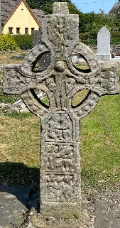
Duleek-Bellewstown Parish Newsletter 20th September 2026
Fr. Stephen Kennedy IVE, Adm. Twenty-Fourth Sunday - year A
Fr. Brendan O’Rourke IVE, C.C.
Parochial House, Parish Secretary:
Duleek, Caroline Doyle
Co Meath, A92 E085 Tel: 041-9823205
www.duleekbellewstownparish.com; email:duleekparish@gmail.com
Duleek is part of the Meath Diocesan Pastoral Area of Parish Office Hours:
Beauparc, Slane & Rathkenny. Tuesday: 10.00am - 4.00pm
Mass Intentions Wed & Thurs: 9.00am - 4.00pm

Saturday 19th September  Memorial of St Januarius | 7.00pm | Henry & Betty Lowth & dec. family.
Sunday 20th September  Twenty-Fifth Sunday in Ordinary Time | 9.00am | Christy & Hanna Coleman
Sunday 20th September  Twenty-Fifth Sunday in Ordinary Time | 10.00am (Bellewstown) | Jack McGuinness.
Sunday 20th September  Twenty-Fifth Sunday in Ordinary Time | 12.00pm | David Keelan; Mark O’Brien; Noel Maher; Fr Seamus McManus.
Tuesday 22nd September | 9.30am | People of the Parish.
Wednesday 23rd September  Memorial of St. Padre Pio | 9.30am (Bellewstown) | People of the Parish.
Thursday 24th September | 9.30am | Agnes Taaffe.
Friday 25th September | 9.30am | Christy, Sarah & Sean Weldon.
Saturday 26th September  Memorial of Ss. Cosmas & Damian, Martyrs | 7.00pm | Tina Bohan M.M; Jim Callaghan M.M; Eithne Heasley; Paddy, Eileen & Ann Kevitt; Patrick & Ellen McKenna & dec family; Michael & Ann Kevitt & dec family; Mary & Joe Smith.
Sunday 27th September  Twenty-Sixth Sunday in Ordinary Time | 9.00am | People of the Parish.
Sunday 27th September  Twenty-Sixth Sunday in Ordinary Time | 10.00am (Bellewstown) | Deceased of Moore family.
Sunday 27th September  Twenty-Sixth Sunday in Ordinary Time | 12.00pm | Angela Faye M.M; Owen Farrelly 1st Ann; Kelley Noone; Peter Heeney; Liam O’Halloran; Anne O’Brien; Patrick Teeling; Mary, Denis & Loretto Walsh.

SUNDAY MASS PLATE COLLECTION: € 1,096.29
SHRINES (Duleek): € 128.71
PARISH DEVELOPMENT FUND: € 1,052.15
Duleek Parish Development: IBAN IE26 AIBK 9323 9604 1618 61

Community notices
Bellewstown will host the National Hospice Coffee Morning on Thursday 24th of September 2026 in Bellewstown Parish Hall from 9.00am to 12.00pm. Coffee & cake €5; Raffle 2 lines €5. Contact Linda 086-8450339, Paula 086-0842619 or Kate 085-70688373. Every Euro raised goes directly to East Meath Hospice.
Duleek Woman’s Forum are holding Line Dancing Classes in the Parish Centre every Monday 10am-11am for beginners. Dancing continues until 12noon. Pay as you go. Everyone welcome.

To Assist at the Masses All kindly check in at the sacristy before Mass
St. Cianán’s Ministers of the Word 20th & 27th Sept
Saturday Vigil Catriona Dillon & Marina Nolan Sun. 9am James McKenna & Frank Ryan
Sun 12 noon Geraldine Potter Redmond

St. Cianán’s Ministers of Holy Communion 26th & 27th Sept - Team A
Sat Vigil 7pm Paul Ryan; Denise Duff; Susan Gleeson Sun. 9am John McWeeney; Richard Bowden; Keith McDonald.
Sun 12noon Joe Martin; Bryan O’Sullivan; Stephen McKee.

St. Thérése’s Minister of the Word Sunday 27th Sept Joe Collins
Ministers of Holy Communion Sunday 27th Sept Una McGuinness & Sindy Nelson

If you prefer to use this QR just scan your phone over it.

er it and follow the guide.

Adoration & Eucharistic Benediction |  |  |  | Sacrament of Confession
 | St. Cianan’s, Duleek | Bellewstown |  |  | St. Cianan’s, Duleek | Bellewstown
Tuesday | 6.00pm - 7.00pm |  |  | Saturday | 6.00pm – 7.00pm
Wednesday |  | 8.30am - 9.30am |  | Sunday |  | 10.45am – 11.15am
Saturday | 5.00pm - 6.00pm
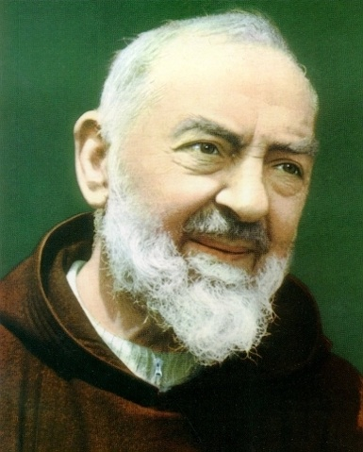

Feast Day of St. Padre Pio:
This coming Wednesday, the Church celebrates the memorial of St. Padre Pio. Known throughout the world as one of the great saints of the Church, Padre Pio went to his heavenly reward on 23rd September 1968. He spent many hours throughout the day in the Confessional, and queues of people used to come to his Franciscan convent in San Giovanni Rotondo, Italy, in order to hear his advice. He received the stigmata (the wounds of Christ) in his hands, feet and side. He had a great devotion to Our Lady, and he used to pray the Rosary several times a day. A young Polish priest named Karol Wojtyla came to visit him in 1947, and they maintained contact for many years. In 1962, Fr Wojtyla asked Padre Pio to pray for healing for a friend of his. Padre Pio is reported to have commented, “To this one cannot say no.” Fr Wojtyla’s friend was miraculously healed days later. In 1978, Fr Wojtyla became Pope John Paul II, and he declared Padre Pio a saint in the year 2002. Mass will be celebrated on Wednesday morning at 9.30am in Bellewstown, in honor of St. Padre Pio.

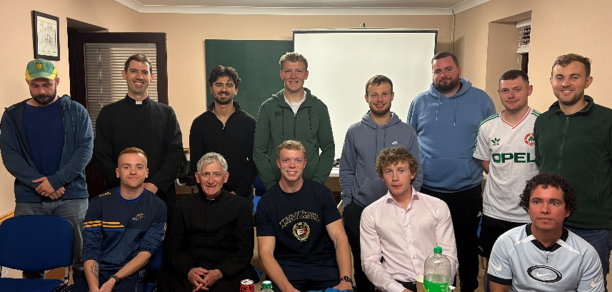
St. Cianan’s Men’s Rosary Group:
Last Friday, the monthly meeting of St. Cianan’s Men’s Rosary Group was held. Young men from our parish gathered together with Fr Stephen and Fr Brendan in order to pray the Divine Mercy chaplet in St. Cianan’s Church, after which there was a short catechesis in the Prayer Rooms, followed by pizza. We pray to St. Cianan for the growth in faith of all of the young people of our parish.


Sacrament of Confirmation 2027:
Our parish Confirmation ceremony will take place next year on Monday 8th March 2027, with approximately 100 children from our five schools receiving the sacrament. Bishop Tom Deenihan recently made short video and wrote a letter to all of the families of children in the diocese who will be receiving the sacrament. The full video can be viewed here: https://www.youtube.com/watch?v=of5MGZOSBLg. He encouraged the children to choose the name of a saint as their Confirmation name, and explained the importance of the role of the sponsor. The bishop also mentioned the importance of the Pledge, which is a promise that the children take to abstain from alcohol and drug use. Parents of children receiving First Holy Communion or Confirmation next year are once again reminded to collect the enrolment form from the sacristy after the weekend Masses or from the parish office. The forms will then be handed in during the enrolment Masses in early October: for First Holy Communion children, on Tuesday 6th October at 7.30pm; for Confirmation children on Thursday 8th October at 7.00pm.


Second Collection next Weekend:
Next Sunday a second collection will take place at our Masses. This collection will be for our parish’s contribution to the Fleming Fund which supports sick and retired priests in the Diocese of Meath. This collection takes place at this time in all parishes across the diocese.


World Youth Day: Seoul 2027
The Diocese of Meath is organizing a pilgrimage to World Youth Day, which will take place in the summer of 2027 in Seoul, South Korea. Young people from around the world will gather to share their faith from 27th July - 10th August 2027. The trip is open to those aged 19 to 30 years, at a cost of approx. €2750. This includes group flights and accommodation. For more information, email: meathyouth@gmail.com, or go to www.dioceseofmeath.ie/youth.

